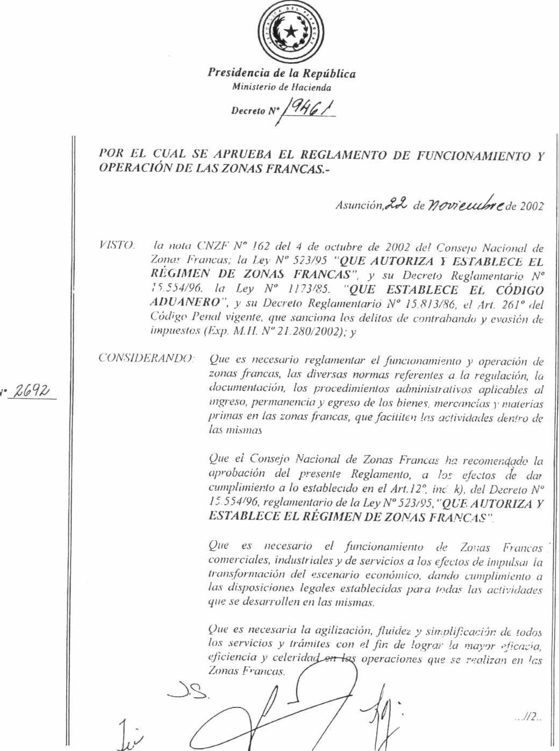

Presidency of the Republic

Ministry of the Treasury

Decree Nº 19461

Asunción, November 22nd 2002.

Article 1st . (Modified by Art 2nd of Decree No 21309 June 2003.) The regulations on the function and operations of Duty Free Zones are hereby approved, according to the following chapters:

- OBJECTIVES

  - The main objective of these regulations is to establish rules and administrative procedures that will enable the efficient operation of the Duty Free Zones and which will be applied to the entry, permanence or exit of goods, merchandise, and raw material in the referred DFZs with the purpose of facilitating their activities.

  - These regulations can be modified and/or amplified by the Executive Branch upon proposal of the National Council of Duty Free Zones and if they were thus modified, the modifications will be in force for the concessionaires the day after they were published.

- ACTIVITIES OF THE DUTY FREE ZONES

  - All sorts of commercial, industrial and service activities can be performed in the DFZs of the Republic of Paraguay, with only the restraints established in Law No 523/95 and in its corresponding Regulatory Decree No 15.554/96, as well as those established in these Regulations and in the Internal Regulations for Concessionaires of each Duty Free Zone.

2.2. For activities that might harm the environment, such as the ones that generate the emission of dust, smoke, aggressive odors, vibrations, electromagnetic or electrome-chanic disturbances, radiation or air and water pollution, preventive mechanisms should be adopted to avoid the before mentioned inconveniences.

2.3. The users of the DFZs under no circumstance will be allowed to hire spaces in the Duty Free Zone for weapon and ammunition storage, also of inflammable material; for political meetings, activities against morality, nor for other activities that may represent a hazard for human health, animal or vegetable sanitary conditions, or for the security and preservation of the environment, except for those activities which are considered standard industrial procedures.

- CONCESSIONAIRES

  - A concessionaire is a private legal entity which through an agreement with the Executive acquires the right to open, administer, and exploit a private Duty Free Zone, under the control of the Council of Duty Free Zones, exerted through its Executive Directorate.

  - The concessionaire will be entitled to the rights and obligation established by Law No523/95 and the corresponding Regulatory Decree No 15.554/96.

  - The user of a Duty Free Zone can only start his activities when the Council of DFZs has approved the Internal Regulation of the private DFZ submitted by the concessionaire and the infrastructure determined by the Art. 22nd of Decree No 15.554/96.

  - The concessionaire, before starting his activities, should request an inspection of the DFZ by the Council of DFZs to check the infrastructure, including machinery installations, equipment, security, public health and working conditions as established by the Code of Labor Law.

  - The concessionaire is allowed to establish or authorize areas or locations especially assigned for exhibits or showrooms for goods manufactured or not by the users of the DFZ and their use will imply the payment of a price to be determined by the concessionaire, with the previous approval of the National Council of DFZs.

  - If any breach or infringement of the Regulation was performed by the concessio-naire, the fines or punishment to be applied to him will be those established in Chapter IX of Regulatory Decree No 15.554/96 and in the Concession Agreement.

  - Any controversy that might arise between the concessionaire and the users of the DFZs related to the interpretation of Law No 523/95, the contracts implied, the Regulations for the Functioning and Operations of DFZs and the Internal Regulations of the DFZ should be treated according to the rules established in Chapter X of the Regulatory Decree No 15.554/96 and the Concession Agreement for the solving of controversies.

  - In case a DFZ concession contract were revoked , the executive, through the National Council of DFZs will be responsible for its administration until the requirements established by Decree No 15.554/96, Chapter IX are fulfilled.

  - The concessionaire is to design his DFZ’s own Internal Regulations where, notwithstanding other regulations, the rules related to common space, schedules, the entrance and departure of people and means of transportation, the minimum requirements for all sort of contracts and invoicing procedures for common services or the like will be established.

  - The concessionaire will strictly apply the principle of non discrimination in relation to the users and the fees established. The concessionaire is not allowed to limit the user’s rights to introduce merchandise of any nature and origin, except those specifically forbidden by Law 523/95 and Decree No 15.554/96.

  - The concessionaire will submit a copy of the users signed agreement to the Executive Directorate to the effect of checking and confirming their condition as users according to what Decree 15.554/96 establishes.

  - The concessionaire should provide a scale to control the weight of the means of transportation.

  - The concessionaire should present the National Council of Duty Free Zones with a monthly report on the actual and accounting inventory prepared by the users.

- ABOUT USERS

4.1. The Duty Free Zone user is the natural or legal person, of private nature, with foreign or local domicile who acquires the right to develop any of the activities listed in Chapter II of Decree 15.554/96, which regulates Law No 523/95

4.2. The user obligations include: to comply with the laws, decrees, regulations of operations, the internal regulations of the DFZ, the contract of the user, the instruction bulletins generated by the Executive Director and the concessionaire, according to the rules established in Law 523/95, specifically in its art 31st.

4.3. The user will be allowed to transfer his contract to a third party previous consent of the concessionaire, in accordance with the legal regulations in force, and will report these arrangements so as to register the new user under the Executive Directorate of the Council of Duty Free Zones.

- ABOUT GOODS, MERCHANDISE AND RAW MATERIALS IN THE DFZs.

5.1.1.Procedures to introduce goods, merchandise and raw materials in the DFZs, will be initiated through Customs Administrations, duly authorized to operate, according to rules established in these regulations.

5.1.2.The goods, merchandise and raw material from third countries introduced by the entry Customs, in transit to the DFZ should travel with the documents required by Law 1178/85 which enact the Customs Code of Law, and the corresponding regulatory Decree No 15.813/86.

5.1.3. For the entry of goods, merchandise and raw material in the DFZ, besides the documents required by the National Customs Directorate the items listed below will also be necessary:

- Entry application form ZF1. The Customs broker should complete this form, in two copies, as part of the documents required by the legal rules in force, the first copy for the Entry Customs Office and the other for the DFZ introduction procedures.

- The goods, merchandise and raw materials should be consigned to some DFZ user and include in a visible location the following text “IN TRANSIT, CONSIGNED TO DFZ USER, CONCESSIONAIRE SUCH AND SUCH.” In cases where the merchandise does not travel in the previously stated conditions their respective consignees or owners should endorse the bill of lading and commercial invoice in favor of a user of the DFZ stating the nature of the endorsement (transfer or depo-sit). The endorsement should be signed, with the name of the endorser clearly written below, and legibly stating name and address of the owner of the goods, merchandise or raw materials. In case the endorser is a legal entity the following text should be added “On behalf of ......” along with the documents of the corporation which prove the endorser is legally able to perform such act.

5.1.4. The goods, merchandise and raw materials destined to the DFZs can only remain in the Entry Customs or port or airport for the time strictly necessary, no more than 24 (twenty four) hours for its registration and shipment, and only when the established documentary requirements are met.

5.1.5.The goods, merchandise and raw material moved to or from a DFZ should be transported in cargo vehicles, duly registered and warranted by the pertinent authorities.

5.1.6. All kinds of goods, merchandise, raw material and services can be introduced in DFZs except for weapons, ammunitions and other items that may jeopardize morality, health and sanitary conditions of vegetable and animal species as well as security and the preservation of the environment.

5.1.7. Entry Customs Bureaus will demand the documents required by the laws and regulations in force, and will register the incoming merchandise and arrange for custody and sealed straps of these, also designating customs personnel who will accompany the merchandise, based on requests for transportation and the boarding of the merchandise to its destination. Concessionaires should be informed through a computer net or by any other means at hand about the authorized operation and will also state the itinerary of the means of transportation. The time necessary for these means of transportation to cover the distance between the Customs Bureau and the DFZ will also be established.

5.1.8. The goods, merchandise and raw materials should comply with all Customs Controls, the rules of these Regulations and the ones established by the concessionaire for entering the DFZs, notwithstanding the documentary controls that the authorized public institutions may eventually exert in ports, airports or while the merchandise is being transported to the DFZs.

5.1.9. The concessionaire has the right of rejecting the entry of certain goods, merchandise or raw materials when the available facilities do not allow the storing of such goods for safety reasons or for lack of storage capacity. If the user considers this restriction not founded he can appeal to the Executive Directorate of the National Duty Free Zones, which will make the corresponding decision.

5.2. ENTRY PROCEDURES

5.2.1 The concessionaire should establish in the Internal Regulations the procedures to be fulfilled for the entry of goods, merchandise and raw materials in the DFZ, including the following check points as a minimum:

- Gate Control
. The control office at the gate should register the data related to the vehicle, transportation company and driver to authorize its entry into the DFZ. To this effect it will grant the transporter an identification card for entering the free parking area.

- Platform Scales Office
. The platform scales office will weigh the vehicle and will issue two tickets reporting its weight, which will be attached to the other documents of the merchandise for later check ups.

c. Free Parking Area
. The concessionaire will open an area in the Duty Free Zone which will be called Free Parking Area. This area will be used as an in transit space for the cargoes newly brought into the DFZ , where their respective documents will be duly checked by customs officers before being released for entry in the DFZ with destination to the users warehouses.

5.3. MERCHANDISE CHECK UPS

5.3.1. The goods, merchandise and raw materials will be verified, classified and appraised at the warehouse of the user so as to register and confirm the corresponding inventories. To this effect the customs broker will request the presence of Customs officials, National Council of DFZ clerks and the concessionaire.

5.3.2. If any differences or anomalies were found, the clerks on duty will proceed to report, through special records, the precise features of the merchandise actually introduced.

5.4. PERMANENCE

5.4.1. The terms for the permanency of merchandise in the DFZ will have no limits, however, when it is considered justified especially due to reasons derived from the nature or type of the merchandise, the concessionaire can establish limits to the duration of the above mentioned terms and take the necessary measures to ensure compliance.

5.4.2. The handling of the goods, merchandise and raw materials introduced in the DFZs, including their entry, moving, permanency, destruction or departure will be performed in accordance to Chapters VII and VIII of Decree No 15.554/96

5.4.3.The users should keep permanent computer records of the goods, merchandise and raw materials so as to allow the verification of such at any time.

5.4.4.If the intervening authorities found any falsehood in the declaration of goods, merchandise and raw materials addressed to the user, they should proceed to state it in written minutes and will report these immediately to the official higher authorities who will take the measures or apply the punishments established by the law.

5.4.5. In all cases of transportation, storage, transformation, assembling, fractionating, mixing or industrializing, of any sort of components of the merchandise in stock in the DFZs, the users and all personnel connected to these operations should comply with the technical rules related to sanitary conditions, labor safety, treatment of effluents and industrial waste, and with any other rule applicable to these procedures. In general, users should demonstrate that they have acted diligently to avoid any harm to people and/or the environment.

5.4.6. The users of a DFZ can at any time request authorization from the concessionaire, and this from the Executive Directorate of the Council of DFZs and the General customs Bureau Directorate, to destroy merchandise stored in their warehouses, having previously complied with the requirements established by the law.

5.4.7. In the case of destruction of merchandise in the DFZ the concessionaire will be held responsible for damages to the environment only if he did not follow the procedures established by the law.

5.4.8. To the effects of the payment of tributes or the Duty Free Zone tax on goods deemed derelict, the fiscal value determined by the Directorate of the Customs Bureau will be applied. In public auctions the fiscal value will be either the value assessed for auction or the value actually obtained at the auction, whichever the higher.

5.5. STORING AND STOWING

5.5.1. In accordance to the terms of the contracts between user and concessionaire, the merchandise can be stored in warehouses or outdoors, and will comply with the rules generally accepted so as to allow simple access to the merchandise for verifications when such controls are considered necessary. The rules for the storing and stowing away procedures should be established in the Internal Regulations of the concessionaire.

5.6. DAMAGES AND LEAKAGE

5.6.1.If the concessionaire confirms loses due to leakage or packing anomalies in the merchandise, he will inform the user to immediately proceed to repairs, being held responsible for the damages generated. Were repairs impossible to perform the concessionaire will issue a Damage or Leakage statement, having previously checked their existence.

5.6.2.If any damages or leakage were found in the merchandise stored in the warehouses of the companies operating in the DFZs, the user on his own should report this immediately to the concessionaire, who should do the same to the Executive Directorate of the National Council of Free Zones, as well as to the Customs Bureau, which will acknowledge and register it, and apply legal measures.

5.6.3. The concessionaire will not be held responsible for damages, leakage, fire and loses due to acts of God, force majeure, defective products, weather conditions or packing flaws which the merchandise undergo while in storage in the DFZ he is in charge of.

5.7. OPERATIONS

5.7.1. The user will be allowed to perform commercial transactions with other users of the DFZ. When these imply the alienation of goods and merchandise, they will require the previous authorization of the concessionaire. Said authorization will be onerous and the documents required should adjust to the Internal regulations of the DFZ.

5.7.2 Several other commercial operations could be executed with the merchandise stored in the DFZs, always in accordance to legal requisites.

5.8. EXIT

5.8.1.The control of outgoing goods will be the responsibility of the Customs Bureau located in the DFZ.

5.8.2. The goods, merchandise and raw material that exit the DFZs should comply with the requirements of Customs Laws, and those established in these Regulations and in the Internal Regulations of the concessionaire of the DFZ.

5.8.3.The exit of goods, merchandise or raw materials from the DFZs to third countries or other DFZs or to Customs Territory, will trigger a new customs operation, which should adjust to the rulings of the Code of Customs Law and its Regulatory Decree No 15.813/86, as well Law No 523/95 and its Regulatory Decree No 15.554/96.

5.8.4.The Customs broker or the user should present the Exit Request Form (ZF2) to the concessionaire, at least 24 (twenty four) hours before the departure of the merchandise.

5.8.5.The ZF2 will be introduced in the Inventory System, and an acceptance number will be attached. The stock of the outgoing merchandise will be checked, as well as the payments due to the concessionaire and the DFZ tax. If any anomalies were found, customs officers will act in accordance to the law.

5.8.6.The control of the merchandise in relation to its export dispatch will be executed in the warehouses of the users, in the presence of the appropriate clerks, designated by the Executive Directorate of the National Council of DFZs, the Directorate of National Customs Bureau, and a representative of the concessionaire.

5.8.7.The National Customs Bureau is responsible for the control of the goods, merchandise and raw materials on route to third countries from the DFZ until the certification of its departure through the exit Customs Bureau.

5.8.8. Any dislocation of goods, merchandise and raw materials of foreign origin and on route to other DFZs or to third countries will be dealt by legally authorized Customs Brokers registered before the Directorate of the National Customs Bureau.

5.8.9. The concessionaire should establish through the Internal Regulations of the DFZ the standards for retail operations within the DFZ.

- INVENTORY CONTROL

6.1. The control of inventories in the DFZ will be ruled by these Regulations.

6.2. The National Council of Duty Free Zones, through its Executive Directorate can at any time determine the check up of an inventory at random or the inventory of any given user.

6.3. Concessionaires and users of the DFZ should set standardized rules and promote adequate information and inventory control systems.

6.4. The concessionaire should register through computer software the inventories and a complete record of the document used to implement any changes in the status of the merchandise in the DFZ he is responsible for,:
- Keeping the information updated daily;
- Introducing data according to the information provided by the documents on the entry, exit, damage or leakage;
- Maintaining the files which generated the changes numerically organized for a year, and,
- Providing the balances and reports on variations required by the appropriate authorities.

  - The concessionaire may request from users the execution of inventory controls backed by Consulting Firms vastly knowledgeable in the field.

  - The user will have 48 (forty eight) hours to report any difference that he may discover between the data stated in the documents and the quantity or features of the goods, merchandise or raw material introduced in the DFZ, being solely responsible for any breach in Customs Regulations subsequently detected.

  - The National Council of DFZs, through its Executive Directorate and the Directorate of the Customs Bureau will access the information provided by this system periodically checking its reliability and validity.

- CHARACTERISTICS OF THE SYSTEM

7.1. The inventory system should provide at least the following information:

- Users data
- User code
- Name, address,. Phone number.
- Board of Directors and administrative managers.
- Date of the User’s Agreement and its duration.
- Persons duly authorized to sign entry and exit documents of the merchandise and any other document of the company.
- Person in charge of the warehouses hired by the user.

- INFORMATION SUMMARIES THE SYSTEM SHOULD PROVIDE

8.1. General Balances on Inventories by physical units and values. (Entry CIF)

8.2. Detailed movements of inventory batches (entries, transfers, exits etc) with their respective dates and document numbers.

8.3. Balance and movements of inventories by product code, in relation to each user, in physical units and values. (Entry CIF).

9. PERIOD OF MAINTAINING THE DOCUMENTATION ON LINE AND ITS FILING.

9.1. The system should maintain on line the movements for at least two months, except in the case of open batches (lots within the inventory) which will be kept until they exit the facilities.

9.2. The concessionaire will be held responsible for maintaining the original documents for a period of 5 (five) years and the summary lists for a period of 4 (four) years.

10.INTERNAL FORMS

10.1. Application for the entry of goods, merchandise and raw materials in the Duty Free Zones (ZF1)

This form should be presented to the concessionaire 24 (Twenty four) hours previous to the entrance of merchandise, with it corresponding registration code.

10.2. Application for the exit of goods, merchandise and raw material from the Duty Free Zones (ZF2)

. This form will be presented to the concessionaire 24 (Twenty four) hours before merchandise is withdrawn, and should accurately state its entry code.

11. THE TAX REGIME

11.1. The tax regime for the concessionaires and users of the Duty Free Zones will be applied in accordance to the rules established in Chapter VI, Section I through VI of Decree No 15.554/96, Regulatory to Law No 523/95.

11.2. The user of the Duty Free Zone shall be registered in the Tax Payers Sole Registry, having the compulsion of stating in the corresponding form the type of tributary obligation he is submitting to.

A User who, at the issuing of these regulations is already registered in the Tax Payer Registry, as a taxpayer for imposts administered by the Sub Secretary of State for Taxation of the Ministry of the Treasure, and who has not yet registered as user of the Duty Free Zone, should update all his personal data through form 402 or 403, whichever more appropriate, stating in the slot “reasons for change” – user of duty free Zone, attaching the documentation that proves his status as a user of a DFZ.

The user who has elected to pay solely the income tax, should employ the book stated by the law for businessmen in general: Accounts Book and Inventory Book. If he chose to pay solely the Duty Free Zone Tax, he will have to use the Book of Entries and the Book of Exports which will be signed and seal by a public officer assigned by the Sub secretary of Taxation.

If the user chose to submit to both taxes he should employ the books required in each case.
The user who at the same time operates out of the boundaries of the DFZ, should have separate accounting for each sort of activity.
The Ministry of Treasury through the Sub-secretary of Taxation, is empowered to regulate how these rules should be applied in relation to tributary matters.

12.INFRACTIONS AND PUNISHMENTS

12.1 If the National Council of DFZs confirms the existence of irregular situations which affect or may affect the normal activities of the DFZ, it will notify the concessionaire so as to take adequate and corrective measures to check the infringements and to cease or correct the breaches. Furthermore it will apply the punishments contemplated in Chapter IX of Decree No 15.554/96, Regulatory to Law No 523/95

12.2. The user who breaches the law, or infringes upon any rule established in Articles 97 and 98 of Decree No 15.554/96 will be punished by the National Council of DFZs, through its Executive Directorate, who will apply the corresponding fines according to the following cases:

- When the merchandise introduced in the country and consigned to the DFZ is not transported to the DFZ in the time terms established by the Entry Customs Bureau, according to rule 5.1.7. of these regulations, a fine of up to 3 (three) per cent of expected investment or of the total value of the merchandise, whichever value is higher will be applied.

- The exit of goods from the DFZ without a Customs broker dispatch will be enalized with a fine of up to 3 (three) per cent on the expected investment or of the total value of the merchandise, whichever value is higher.

- Any falsehood in the declarations of the imported or exported goods, to or from the DFZ or Customs territory, on the quantity, quality or value , including the goods sold at retail prices, will be penalized with a fine of up to 2 (Two) per cent of the value of the merchandise.

Article 2nd. The Executive Directorate of the National Council of DFZs will be in charge of controlling the strict compliance to the present Regulations, adjusting its acts to the rules established in Law No 523/95, its regulatory rules and other laws in accordance with it.

Article 3rd. The present decree will be signed by the Ministers of the Treasury, Trade and Industry and Public Works and Communications.
There are three illegible signatures at the bottom of the document.

I, the undersigned, José Luis Guggiari, Public Translator Registered under Number 746, before the Supreme Court of Justice of the Republic of Paraguay, declare upon oath that the document translated above is a faithful and correct translation into English from the original document in Spanish which I have at hand, in faith and testimony whereof have hereunto subscribed my name and fixed my seal in Ciudad del Este, Alto Paraná, Paraguay, on the 29th day of March of the year two thousand and six

José Luis Guggiari
Traductor Público
Reg. No 746

